Averaged vs. Replicate-Level Flux: Model Comparison (Claude)
source("C:\\Users\\savan\\OneDrive - San Francisco State University\\ProjectData\\GitHub\\DepositionSFB\\code\\R\\setup.R")
Warning: package 'readxl' was built under R version 4.4.3
Warning: package 'writexl' was built under R version 4.4.3
Warning: package 'ggplot2' was built under R version 4.4.3
Warning: package 'purrr' was built under R version 4.4.3
Warning: package 'gt' was built under R version 4.4.3
Warning: package 'rstatix' was built under R version 4.4.3
Warning: package 'lmerTest' was built under R version 4.4.3
Warning: package 'lme4' was built under R version 4.4.3
Warning: package 'glmmTMB' was built under R version 4.4.3
Warning: package 'ggeffects' was built under R version 4.4.3
Warning: package 'fitdistrplus' was built under R version 4.4.3
Warning: package 'gamlss' was built under R version 4.4.3
Warning: package 'gamlss.data' was built under R version 4.4.3
Warning: package 'gamlss.dist' was built under R version 4.4.3
Warning: package 'brunnermunzel' was built under R version 4.4.3
Warning: package 'patchwork' was built under R version 4.4.3
Warning: package 'cowplot' was built under R version 4.4.3
Warning: package 'rcartocolor' was built under R version 4.4.3
Warning: package 'ggh4x' was built under R version 4.4.3
Warning: package 'scales' was built under R version 4.4.3
Warning: package 'webshot2' was built under R version 4.4.3
Warning: package 'ggdist' was built under R version 4.4.3
Warning: package 'reactable' was built under R version 4.4.3
source("C:\\Users\\savan\\OneDrive - San Francisco State University\\ProjectData\\GitHub\\DepositionSFB\\code\\R\\plotting.R")
source("C:\\Users\\savan\\OneDrive - San Francisco State University\\ProjectData\\GitHub\\DepositionSFB\\code\\R\\modeling_conventions (Claude).R")
source("C:\\Users\\savan\\OneDrive - San Francisco State University\\ProjectData\\GitHub\\DepositionSFB\\code\\R\\statistical_tools_glossary (Claude).R")
knitr::opts_chunk$set(echo = TRUE)
knitr::opts_knit$set(root.dir = 'C:/Users/savan/OneDrive - San Francisco State University/ProjectData/GitHub/DepositionSFB/data')
master_tier5 <- readr::read_csv(
file.path(knitr::opts_knit$get("root.dir"), "master_tier5.csv")
) %>%
filter(Flux > 0, Dist != 48) %>%
mutate(Site = as.factor(Site), Tran = as.factor(Tran),
marsh_edge_type = factor(marsh_edge_type, levels = c("Scarped", "Ramped")))
master_tier5_byrep <- readr::read_csv(
file.path(knitr::opts_knit$get("root.dir"), "master_tier5_byrep.csv")
) %>%
filter(Flux > 0, Dist != 48) %>%
mutate(Site = as.factor(Site), Tran = as.factor(Tran),
marsh_edge_type = factor(marsh_edge_type, levels = c("Scarped", "Ramped")),
Replicate = as.factor(Replicate))

The question this document answers
master_tier5.csv averages every replicate trap at a given Site/Tran/Dist/Month into a single Flux value before any model sees it (average_replicates(), step6). master_tier5_byrep.csv keeps each trap as its own row instead (keep_replicates(), step6), which means the same physical point now contributes ~3 rows instead of 1.
That raises the same kind of question as the marsh_edgeID comparison: does keeping replicates separate actually buy you anything, or does it just add rows that need to be told, via the random-effects structure, that they came from the same point?

The models
# AVERAGED (existing default): one Flux value per Site/Tran/Dist/Month.
model_avg <- glmmTMB(
Flux ~ marsh_edge_type + (1 | Site/Tran),
family = Gamma(link = "log"),
data = master_tier5
)
# REPLICATE-LEVEL: one Flux value per trap. (1|Loc_ID) is required here,
# not optional -- without it, this model would treat 3 correlated traps
# at the same point as 3 independent observations, which is exactly the
# pseudoreplication problem this whole project's modeling_conventions.R
# exists to avoid for Site/Tran. Loc_ID = interaction(Site, Tran, Dist),
# same construction already used for the AR1 model in RQ1-temporal.qmd.
model_byrep <- glmmTMB(
Flux ~ marsh_edge_type + (1 | Site/Tran) + (1 | Loc_ID),
family = Gamma(link = "log"),
data = master_tier5_byrep
)
summary(model_avg)$coefficients$cond["marsh_edge_typeRamped", ]
Estimate Std. Error z value Pr(>|z|)
-0.8898293 0.8562369 -1.0392326 0.2986966
summary(model_byrep)$coefficients$cond["marsh_edge_typeRamped", ]
Estimate Std. Error z value Pr(>|z|)
-0.4653709 0.5527834 -0.8418685 0.3998615

Why AIC alone can’t answer this
nrow(master_tier5)
[1] 499
nrow(master_tier5_byrep)
[1] 1430
AIC(model_avg, model_byrep) is not a valid comparison here – unlike the marsh_edgeID comparison (same data, different grouping label), these two models are fit to genuinely different N. A lower AIC on model_byrep would partly just reflect having ~3x more rows, not a better-fitting model. AIC (and likelihood generally) is only comparable across models fit to the same data.
What’s actually comparable instead:
# 1. The fixed-effect estimate and its precision, side by side (already
# printed above) -- if Loc_ID is doing its job, these should be
# similar. A real divergence is the interesting result, not a bug.
# 2. Diagnostics on EACH model against its OWN data -- this is a fair
# comparison because it's asking "does this model fit its data
# well," not "which likelihood is bigger."
sim_avg <- simulateResiduals(model_avg)
plot(sim_avg)
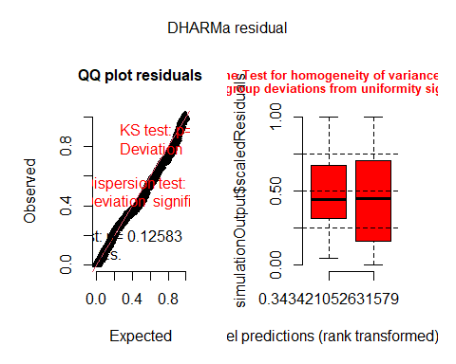
testDispersion(sim_avg)
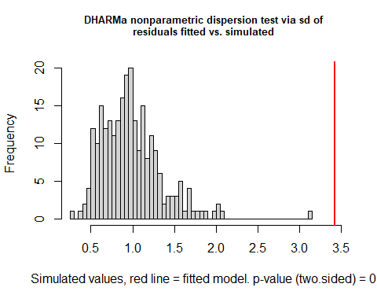
DHARMa nonparametric dispersion test via sd of residuals fitted vs.
simulated
data: simulationOutput
dispersion = 3.4873, p-value < 2.2e-16
alternative hypothesis: two.sided
sim_byrep <- simulateResiduals(model_byrep)
plot(sim_byrep)
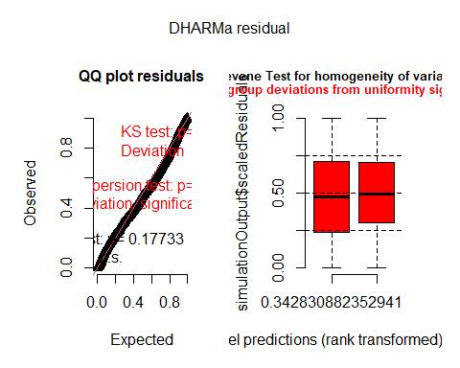
testDispersion(sim_byrep)
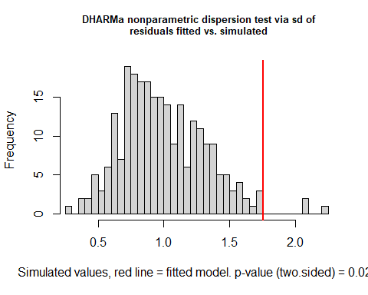
DHARMa nonparametric dispersion test via sd of residuals fitted vs.
simulated
data: simulationOutput
dispersion = 1.7615, p-value = 0.024
alternative hypothesis: two.sided
# 3. Where the variance actually sits, once you can see trap-to-trap
# noise separately from point/transect/site variance -- this is the
# actual scientific payoff of not averaging.
VarCorr(model_byrep)
Conditional model:
Groups Name Std.Dev.
Tran:Site (Intercept) 0.20755
Site (Intercept) 0.45732
Loc_ID (Intercept) 0.92995

What to look for
Question | What tells you
Does keeping replicates change the marsh_edge_type conclusion? | Compare the two coefficient/SE rows above directly.
Is (1\|Loc_ID) actually absorbing the point-level correlation, or is there leftover structure? | testDispersion()/plot() on model_byrep – overdispersion here suggests Loc_ID isn’t fully capturing it.
Was averaging throwing away real signal, or just noise? | VarCorr(model_byrep) – if the Loc_ID (point-level) variance is much larger than the residual (trap-to-trap) variance, replicates within a point were mostly redundant and averaging lost little. If residual variance is large relative to Loc_ID, individual traps varied a lot and averaging was smoothing over real measurement variability.
Which model is more defensible to report as primary? | If both diagnostics look reasonable and the coefficients agree, report the averaged model as primary (Rule 2 default, simpler, fewer assumptions, matches the rest of the project) and cite this comparison as a robustness check – same framing recommended for marsh_edgeID vs. Site/Tran. If they meaningfully disagree, that disagreement is itself a result worth reporting, not something to resolve by picking whichever looks better.

Where this is implemented
- keep_replicates() / master_tier5_byrep.csv: step6_master_analysis_flagtier.qmd, alongside the existing (unchanged) average_replicates().
- Loc_ID construction: same pattern as the AR1 temporal-autocorrelation model in RQ1-temporal (Claude).qmd.
- The general Rule 1a nesting logic this document extends: modeling_conventions (Claude).R.

